**Create base:**

create database base;

use base;

**Create tables:**

Base table

create table tabla(

key int(10) primary key,

notNullField varchar(10) not null,

secondField double(3,1)

);

Every field is written like the example:

fieldName dataType(x) condition(s)

Some data types include

-int

-double (usually used for scientific or stadistic operations)

-decimal (like double but most used in operations with money)

-varchar (CHAR when the length of a field is always the same, like the credit card or phone number)

-date (always formatted like this: Year/Month/Day)

-text (For very long text, like a chapter of a book)

And conditions like

- not null

- primary key

**Primary key:**

-If is only one, is like:

create table exampleTable(

nombreLlave tipoDato **primary key**;

…

);

Composite primary key:

create table exampleTable (

key 1 int(10),

key2 int(10),

**primary key (key1, key2)**

);

**Foreign primary key (the red ones):**

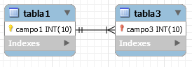

When is only one foreign primary key the base structure is like that:

create table exampleTable1(

key1 int(10) primary key

);

create table exampleTable2(

key2 int(10) primary key,

constraint foreign key (key2)

references tabla1 (key1)

);

**Foreign composite primary keys**

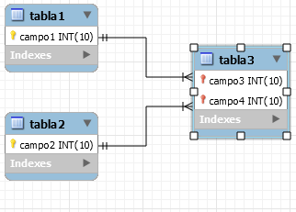

For the example the code will be:

create table exampleTable1(

key1 int(10) primary key

);

create table exampleTable2(

key2 int(10) primary key

);

create table exampleTable3(

key3 int(10),

key4 int(10),

primary key (key3, key4),

constraint foreign key (key3)

references tabla1 (key3),

constraint foreign key (key3)

references tabla2 (key3)

);